The Basko Grand Mall and Adjacent Hotel (Carlos)
The Basko Grand Mall and the adjacent Best Western Hotel serve as painful reminders that significant losses can occur even when the primary structural system suffers little damage. These two buildings are reinforced concrete moment-resisting frames with unreinforced masonry infill walls and were constructed this year (2009). The mall is five stories tall with one portion of the ground floor serving as a parking garage. The hotel is seven stories tall.
The picture below shows the front view of the hotel with the mall on the right. Notice that much of the front façade and structural system suffered very little damage in the earthquake.
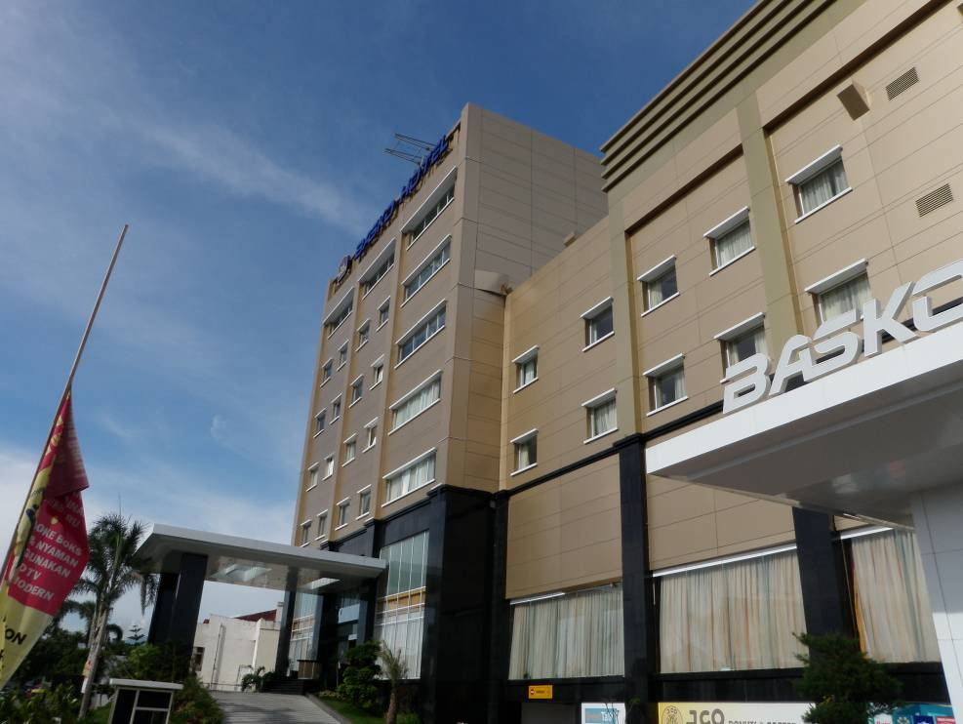
Figure 1: Exterior View of the Basko Mall and the Adjacent Hotel Showing Little Apparent Damage
In spite of these first impressions, the entire facility is closed for business and will be closed for quite some time. The reason is partly because some infill walls suffered out-of-plane failure, but primarily because of major damage to non-structural components. The following photographs show major damage in the second-floor ballroom and the main corridor on the fourth floor.
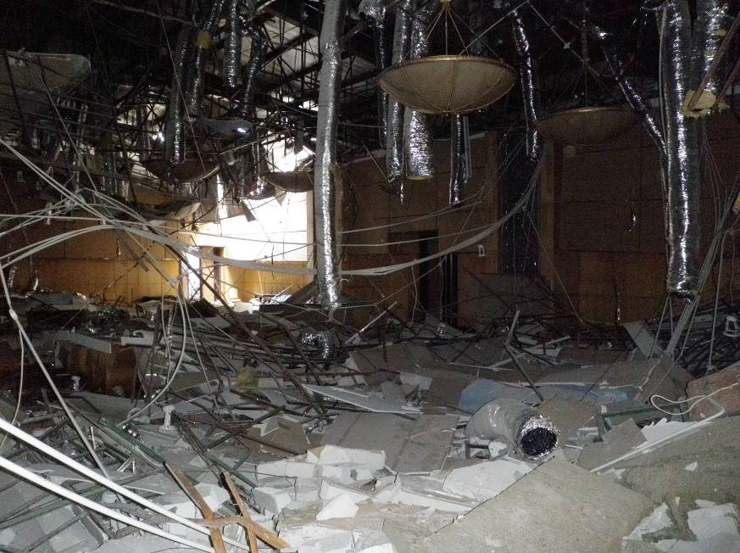
Figure 2: Second-Floor Ballroom in the Hotel with Collapsed Ceiling
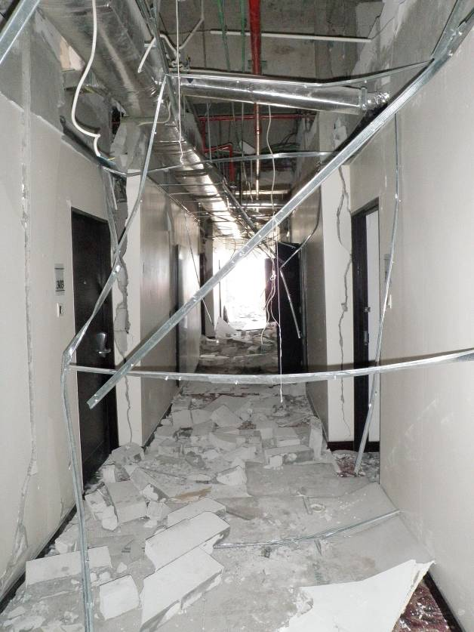
Figure 3: Fourth-Floor Hotel Corridor Showing Major Non-Structural Component Damage
These problems will be expensive to repair, but business interruption will be the significant driver of economic loss; the hotel and every store in the mall is closed at the moment and at least two months will elapse before full operation is restored.

